**Question:**

You are given the csv data that is generated from an order management system that outputs order id, customer id, deliveryPincode, orderDate and items that were ordered in each of the order in a delimited format.

Your task is to build a dashboard that takes the data from the given dataset and presents the orders in the format shown below.

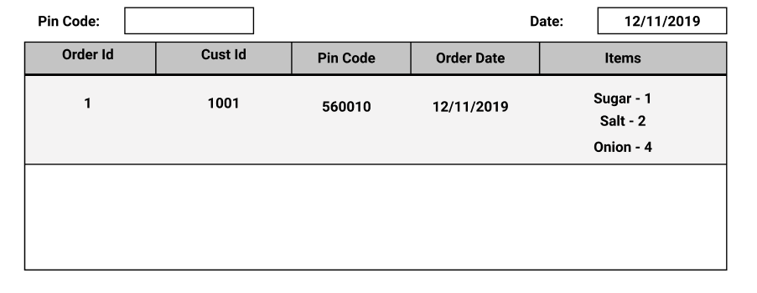

**Features:**

1. Each order should be listed row wise with each of the items on the order as shown in the mock.
2. Items column should be parsed and rendered as shown instead of semicolon delimited.
3. Users should be able to filter the results based on Pincode and Date. Filter should work if both of the filters are used.
4. Users should be able to sort the data (even filtered) based on PinCode or Order Date.
5. Bonus if the user can search based on the Items on the dashboard.
6. Applications should be capable to work with a new set of data in the same format.

**Instructions:**

1. Solution should be built using React.
2. Solution will not be considered if done completely with the help of the available NPM package.
3. Use any version control platform to share the completed code.
4. The Repository should have instructions on how to run the application locally.
5. Candidates are expected to handle minimal errors/corner cases that can occur when using the built application. If an application fails to run or crashes in an expected workflow, it would be rejected.
6. Host the application on any of the platforms and include a link to the solution along with the code.
7. Styling is not a major consideration for evaluation, minimal design is expected.
8. Plagiarism is not entertained, in case you refer to a code snippet from sites like stackoverflow, do comment the link and short description on what problem does it solve.

**Evaluation is based on:**

1. Approach to solve the problem.
2. Choice of Tech Stack.
3. How consistent your coding style is.
4. How you choose to structure your components, and what you decide should be its own component.
5. How you structure your files.